**Special Educational Needs and Disabilities (SEND) Information Report September 2024**

This report sets out information about our provision for children with

Special Educational Needs and Disabilities (SEND) and is updated annually.

**About our school**

St Joseph’s Catholic Primary School is a mainstream primary school which provides for children with a wide range of special educational needs including those with:

* **Communication and Interaction needs** (this includes speech, language and communication difficulties including autistic spectrum conditions)
* **Cognition and Learning needs** (this includes children who have learning difficulties and specific learning difficulties like dyslexia, dyspraxia and dyscalculia)
* **Social, Emotional and Mental Health** **needs**
* **Sensory and/or Physical Needs** (this includes children who have visual or hearing needs, or a physical disability that affects their learning)

Our **Special Educational Needs & Disabilities Coordinator (SENDCO)** is Mrs Susan Lenihan who can be contacted through the School office on Tel: 01295 264284 or [office.3825@st-josephs.oxon.sch.uk](mailto:office.3825@st-josephs.oxon.sch.uk)

The **School governor with a responsibility for SEND** is Mrs Rachel Nutt who can also be contacted through the school office. The SEND Governor meets with the SENDCO and feeds back information to the rest of the school’s governing body.  Our school **SEND policy, Equality and Accessibility Plan** can be found on our school website.

**What is ‘Special Educational Needs’?**

A child or young person has a special educational need if they have a learning difficulty or disability which calls for special educational provision to be made for them. A child or young person is considered to have a learning difficulty or disability if they:

* ‘have a significantly greater difficulty in learning than the majority of others of the same age; or
* have a disability which prevents or hinders them from making use of educational facilities of a kind generally provided for others of the same age’.

(Code of Practice 2014)

**How do we identify and support children with SEND?**

The school uses Oxfordshire County Council’s guidance ‘Ordinarily Available SEND Provision’ (September 2024). The guidance sets out:

* How we identify if a child has a special educational need.
* How we assess children and plan for their special educational needs, and how we adapt our teaching.
* Ways in which we can adapt our school environment to meet each child’s needs.
* How we review progress and agree outcomes and involve you and your child in this.

For pupils that need SEND provision, the school operates a graduated response to their needs. We Assess, Plan, Do and Review and then respond to their needs.

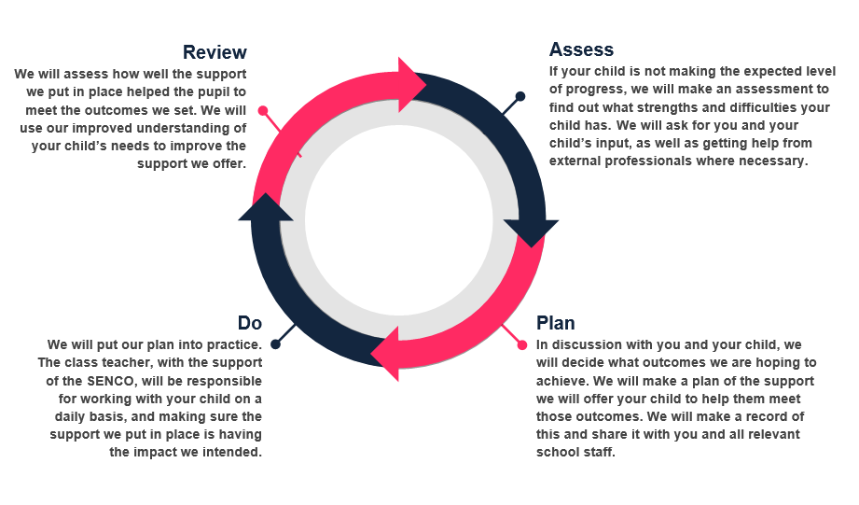

This acknowledges that some children will benefit from specific support from school or external agencies and as such will be identified as requiring SEND support. They will be placed on the school’s SEND register which is monitored centrally by the Local Authority. Other children will require an Education Health Care Plan (EHCP) to support them in their learning.

**How are parents/carers of children with SEND consulted and involved in their child’s education, including their progress towards outcomes?**

Partnership with our parents/carers is key to making sure children with SEND to achieve their full potential at St Josephs. We recognise that parents/carers have vital knowledge, experience and expertise to contribute to the shared view of a child’s needs and the best ways of supporting them. Parent/carers are invited to 3 pupil profile review meetings each year as well as the more informal regular contact at the beginning and end of each day as needed. These pupil profile review meetings are a chance to jointly discuss and share ideas for how best to support the child to achieve the targets set and for what the best next steps are too.

If a child has an EHCP there is also an Annual Review meeting where school, parents and link professionals meet to discuss outcomes. Parents are also invited to provide a written response and to participate actively in the meeting.

Parent/carer questionnaires are also used so that the SENDCo can analyse parent/carer views and further improve provision.

**How are young people with SEND consulted and involved in their education, including their progress towards outcomes?**

Children with SEND often have a great understanding of their own needs and what helps them. Children are encouraged to participate in the decision-making process when we review Pupil Profiles.

If they have an EHCP, they will also be asked to play a role within the Annual Review meeting, usually by completing the All About Me sheet which forms a central part of the meeting and if appropriate for their age and needs, will also be invited to attend the Annual Review.

**What approach do we take to teaching children and young people with SEND? What adaptations are made to the curriculum and learning environment of children with SEND?**

All children are entitled to receive Quality First Teaching through engaging and adaptive teaching. High quality teaching ensures all needs are met. Some children may have difficulties making expected progress and/or not achieving the attainment expected for their age or may experience difficulties socially or emotionally.

At this point we identify groups of children who may need specific support to help boost and accelerate their learning. Their progress is monitored and if they are still experiencing difficulties then we look at identifying if they have a special educational need. As identified in the SEND Code of Practice (July 2014) – paragraph 6.15 ‘A pupil has SEN where their learning difficulty or disability calls for special educational provision., namely provision different from or additional to that normally available to pupils of the same age’.

Our aim is to include all children within our everyday teaching and activities. At times this involves scaffolding, some use of 1:1 and small group teacher or teaching assistant support. This allows individuals to learn at their pace/using resources suitable for their needs and understanding, such as models, images and multi-sensory resources. We make use of quieter rooms and quieter areas to withdraw children if being in the class is causing sensory overload and/or distracting learning. The physical environment is adapted, and specialist resources are considered and made to help provide access to learning. We use a range of resources and specific interventions to meet individual need and support children to access the curriculum.

Some of the SEND interventions and resources we can use in school include:

|  |  |
| --- | --- |
| **Communication & Interaction** | Talk Time  Colourful Semantics  Spirals  PECS/PACT  Individual support for targets set by Speech & Language Therapist  Individualised social stories  Special Time / Activity Box  Lego Therapy  TalkBoost |
| **Reading** | Little Wandle Phonics Keep Up (EYFS/KS1)  Little Wandle Phonics Rapid Catch Up (KS2)  1:1 or Paired Reading  Precision Teaching  Reciprocal Reading (guided reading groups)  Reading Plus Programme (KS2)  Language For Thinking  Project X (Y3/4)  Fuzz Buzz (Y5/6) |
| **Writing** | Ready, Steady Write Fine Motor Programme  Write From the Start Handwriting Programme |
| **Maths** | TT Rockstars  Catch Up Skills sessions closing the gaps  Plus One/Power of 2 (individual programme)  Precision Teaching |
| **Social, Emotional & Mental Health** | Emotional Literacy Support Assistant (ELSA)  Home-School Link worker (Father Hudson)  Place 2 Be Counsellor  Educational Psychology  Calm boxes / corners  Access to Allotment and other therapeutic spaces.  Lunch support  Zones of Regulation  Support & planning for transition times  Soft Landings  Individual visual timetables  Individual Behaviour Plans & Risk Assessments |
| **Motor Skills & Sensory/ Physical** | Occupational Therapy Service & Screening resources  Alternatives to traditional written format e.g. using a device, software, or scribe.  Sensory resource box  Pencil grips, seat cushions, sloping boards  Disabled toilet & changing facility  Physiotherapy programmes  Sensory Circuits  Sensory Room  Sensory garden |

**What specialist expertise does the school have access to?**

There are members of staff within the school who have completed specific training in SEND and we seek guidance from external experts:

***Internally:***

- Special Educational Needs and Disabilities Co-ordinator (SENDCo)

- PFMAC Inclusion Lead

- Trained teachers and Teaching Assistants who can deliver different interventions

- Staff regularly attend training on Special Educational Needs and feedback to other colleagues.

***Externally:***

- OXSIT (Oxfordshire School Inclusion Team) and Oxfordshire SEN Team – we buy into the foundation package which enables us to attend Inclusion Briefings and access phone/ email support with specific queries to help us in improving our inclusive practice and raising the attainment of learners vulnerable to under-achievement.

- Educational Psychologist (a traded service which school can buy into it, if required).

- Special Educational Needs Support Service (SENDSS): who support children with communication and language needs, sensory needs and physical needs

-The Integrated Therapies Team (Physiotherapy, Occupational Therapy, Speech and Language Therapy)

-School Health Nurse

- Child and Adolescent Mental Health Services (CAMHS)

- Early Years SEND Inclusion Team (EYSENIT) Advisory teachers who support our youngest children and their families

Information about these services and what they offer can be found on the [Oxfordshire County Council SEND web pages](https://www.oxfordshire.gov.uk/residents/children-education-and-families/oxfordshire-send-local-offer/parents-carers/children-aged-5-15/5-15-find-local-health-services)

These services provide us with regular assessments and support for individuals and offer specific resources and programmes of work. We can also make referrals to these agencies if, in conjunction with parents, we feel their professional knowledge will support us in making the best provision for a child.

**How do we evaluate the effectiveness of provision made for children with SEND?**

We regularly monitor the provision made for our vulnerable leaners in a variety of ways and we follow a graduated approach - the four-part cycle of assess, plan, do, review as outlined above.

This monitoring includes:

* Use of our ‘Called by Name’ formative and summative assessments-these identify the areas children succeed in and identify what they are finding difficult
* Use of Pupil Profiles, intervention registers to track provision of individuals, monitored by the SENCo.
* Review of Pupil Profiles three times a year with the children and their parents, monitored by the SENDCO
* Tracking progress and attainment of all our vulnerable learners three times a year in line with Pupil Progress meetings and comparison of the data to their peers’ attainment and progress
* Use of progress/attainment data pre and post- interventions which is then used to refine/revise provision and Pupil Profiles
* Use of Pupil Voice to gather pupil opinions on provision and activities at school
* Use of parent/carer questionnaire/surveys

**Joining the school and Moving on**

Applications for pupils, including those with special educational needs and disabilities, to join the nursery and school are processed in line with [Oxfordshire County Council’s published School Admissions rules and policies](https://www.oxfordshire.gov.uk/residents/schools/apply-school-place/school-admission-rules-and-policies/admission-rules#:~:text=If%20a%20school%20does%20not,for%20more%20than%20one%20school.) which can be seen on their website.

We encourage all new children to visit the school before starting. If children join the school in year, we liaise with the former school concerning any special educational needs and disabilities. Similarly, if a pupil leaves our school in the year, we will liaise closely with the new school.

We begin to prepare pupils for transition into the next stage of their education by liaising with the secondary school, and sharing information about special educational needs and disabilities. This might include additional visits, social stories, and group work session in-house to support them.

**What do we do to support the social and emotional development and well-being of children?**

In addition to our Catholic teaching and daily prayer, we provide a range of activities to support emotional and social development for individuals. We have good links with external agencies, all of which offer us advice. We treat mental hygiene with the same priority as dental hygiene for for all our children including participating in calm down and mindfulness activities, themed days like Mental Health Awareness days and ensuring that our staff have training in social and emotional development. All classes use the Zones of Regulation approach for all pupils and, as detailed in our Behaviour Policy, staff are quick to respond to the needs of any children who identify as being in the red, yellow or blue zones or who may appear to staff to be. We use the natural environment of our school to offer therapeutic support. All pupils have opportunity to share their view through their School Council Representatives and are regularly encouraged to share any concerns about school or home with a member of staff. We take bullying very seriously for all children including those with SEND. Anti-Bullying approaches form a central part of our RHE programme and we take part in the annual Anti-Bullying week.

**What support is in place for looked-after and previously looked-after children with SEN?**

Our designated teacher for looked after children and previously looked after children is Mrs Hazel Skiwyrsynska. They can be contacted via the school office. They will work with our SENCO to make sure that all teachers understand how a looked-after or previously looked-after pupil’s circumstances and their SEN might interact and what the implications are for teaching and learning.

Children who are looked after or previously looked after will be supported much in the same way as any other child who has SEND. However, looked after pupils will also have a personal education plan (PEP). We will make sure that the PEP and any SEN support plans or EHC Plans are consistent and complement one another.

**How are pupils with SEND helped to access activities outside the classroom?**

All pupils are included in activities within the school day, before and after school clubs, day and residential trips, following risk assessments, where needed, and in accordance with duties under the Equalities Act 2010. We communicate with parents and pupils when planning trips so that everyone is clear about what will happen.

**What arrangements are there for handling complaints from parents/carers of children with SEN about provision made at the school?**

All details about handling complaints can be found in our Complaints Policy which is published on the school website.

**What are the school’s contribution to the Local Offer and where is Oxfordshire Local Offer published?**

Details regarding Oxfordshire’s Local offer contain a substantial amount of useful information for parents/carers. Contact details of many useful support services can be found here. Please follow this link to find out more: [Oxfordshire County Council Local Offer](https://www.oxfordshire.gov.uk/residents/children-education-and-families/education-and-learning/special-educational-needs-and-disability-local-offer)

As a school we contribute to the County’s Local Offer through attendance at training opportunities and through trialling of new guidance and systems.

**What support is available for me and my family in addition to Oxfordshire’s Local Offer?**

If you have any questions about SEND, or are struggling to cope, please get in touch and let us know. We want to support you, your child and your family.

In addition to the Local Offer mentioned above [SENDIASS Oxfordshire](https://www.sendiass-oxfordshire.org.uk/advice-for-parents) offer great advice and support to families and [Oxfordshire Family Information Service](https://www.oxfordshire.gov.uk/residents/children-education-and-families/information-parents/family-information-service) is also a good source of information.

**If I have a concern regarding SEND or I would like further information, who do I go to?**

In the first instance it is always best to discuss any concerns with the child’s class teacher. If those issues are not resolved then parents should contact school SENDCo and can do this by emailing the office: [office.3825@st-josephs-banbury.oxon.sch.uk](mailto:office.3825@st-josephs-banbury.oxon.sch.uk)